Lab 8 Report

CONTENT
1.Traffic Shifting 2
1.1 Apply weight-based routing 2
2. Request Routing 4
2.1 Route to version 1 4
2.2 Route based on user identity 5
3. Fault Injection 5
3.1 Injecting an HTTP delay fault 5
3.2 Testing the delay configuration 6
3.3 Injecting an HTTP abort fault 7
3.4 Cleanup 8
4. Circuit Breaking 8
4.1 Configuring the circuit breaker 8
4.2 Adding a client 9
4.3 Tripping the circuit breaker 10
4.4 Cleaning up 11

1.Traffic Shifting
Note that the Kubernetes Gateway API CRDs do not come installed by default on most Kubernetes clusters, so make sure they are installed before using the Gateway API:
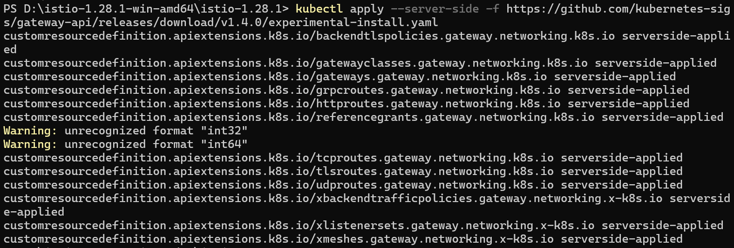

1.1 Apply weight-based routing
To get started, run this command to route all traffic to the v1 version:
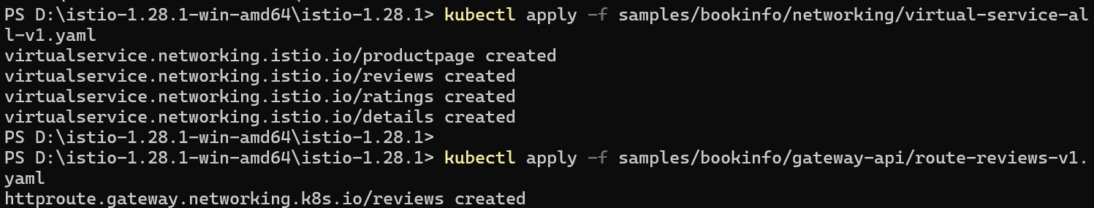
Open the Bookinfo site in the browser.
The URL is http://$GATEWAY_URL/productpage, where $GATEWAY_URL is the External IP address of the ingress, as explained in the Bookinfo doc.
Notice that the reviews part of the page displays with no rating stars, no matter how many times we refresh. This is because we configured Istio to route all traffic for the reviews service to the version reviews: v1 and this version of the service does not access the star ratings service.
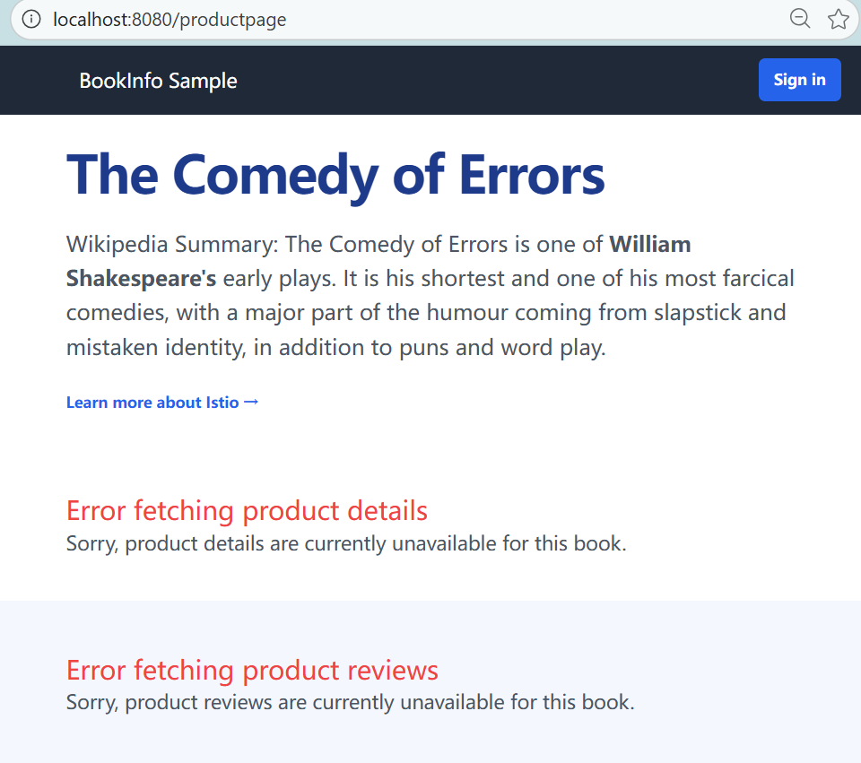
Transfer 50% of the traffic from reviews:v1 to reviews:v3 with the following command:
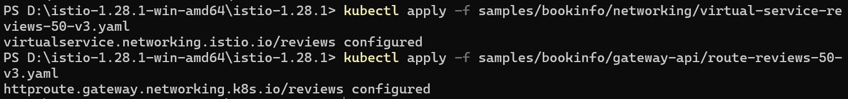
Wait a few seconds for the new rules to propagate and then confirm the rule was replaced:
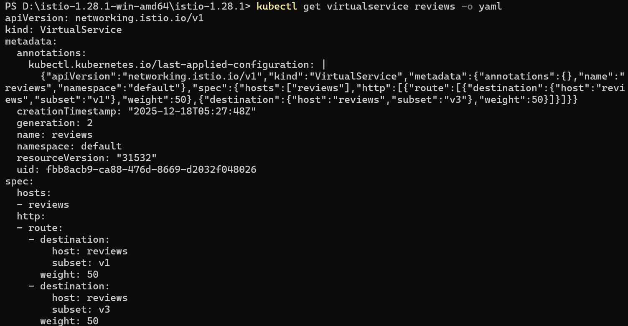
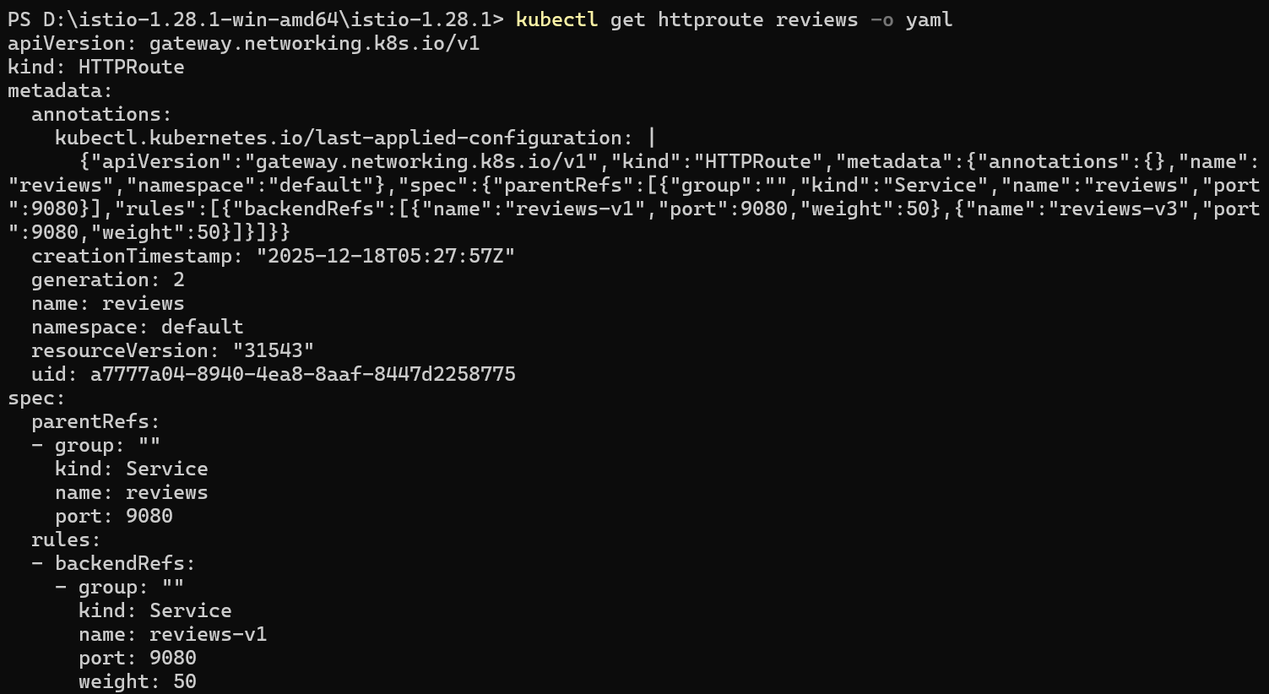
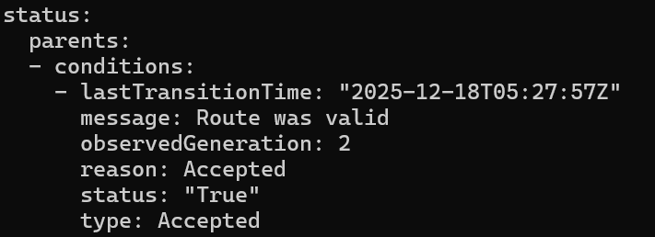
Refresh the /productpage in the browser and we now see red colored star ratings approximately 50% of the time. This is because the v3 version of reviews accesses the star ratings service, but the v1 version does not.
Assuming we decide that the reviews:v3 microservice is stable, we can route 100% of the traffic to reviews:v3 by applying this virtual service:
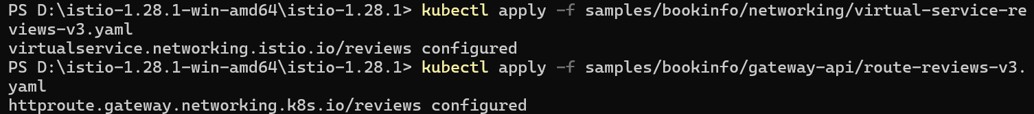

2. Request Routing

2.1 Route to version 1
Istio uses virtual services to define route rules. Run the following command to apply virtual services that will route all traffic to v1 of each microservice:
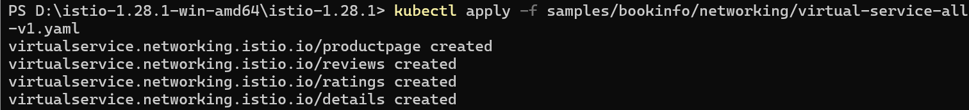
Display the defined routes with the following command:
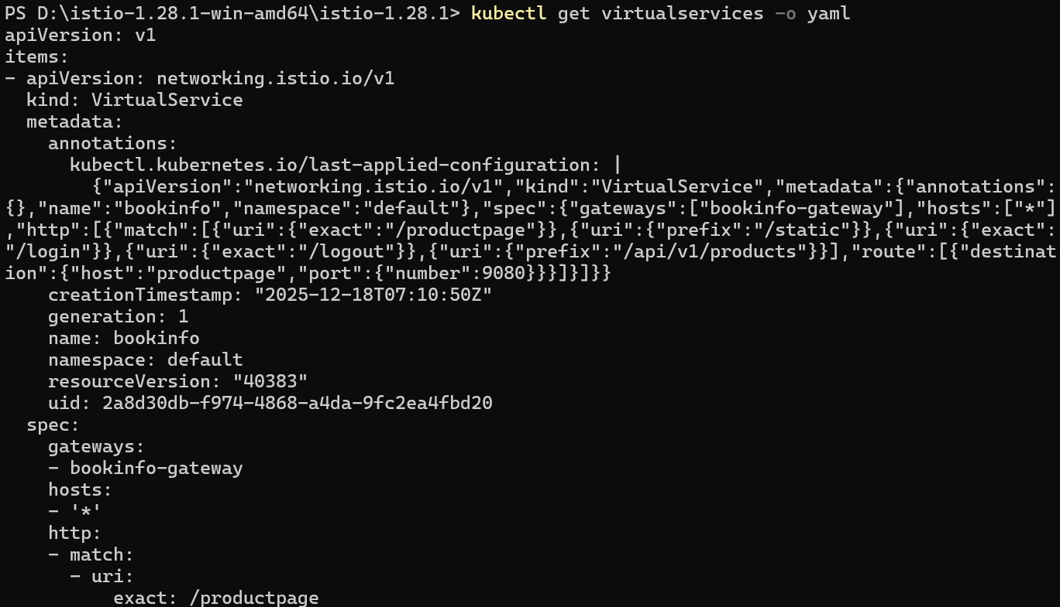

2.2 Route based on user identity
Next, we will change the route configuration so that all traffic from a specific user is routed to a specific service version.
In this case, all traffic from a user named Jason will be routed to the service reviews:v2.
Run the following command to enable user-based routing:
On the /productpage of the Bookinfo app, log in as user jason. Refresh the browser. The star ratings appear next to each review.


3. Fault Injection

3.1 Injecting an HTTP delay fault
Create a fault injection rule to delay traffic coming from the test user jason.
Confirm the rule was created:
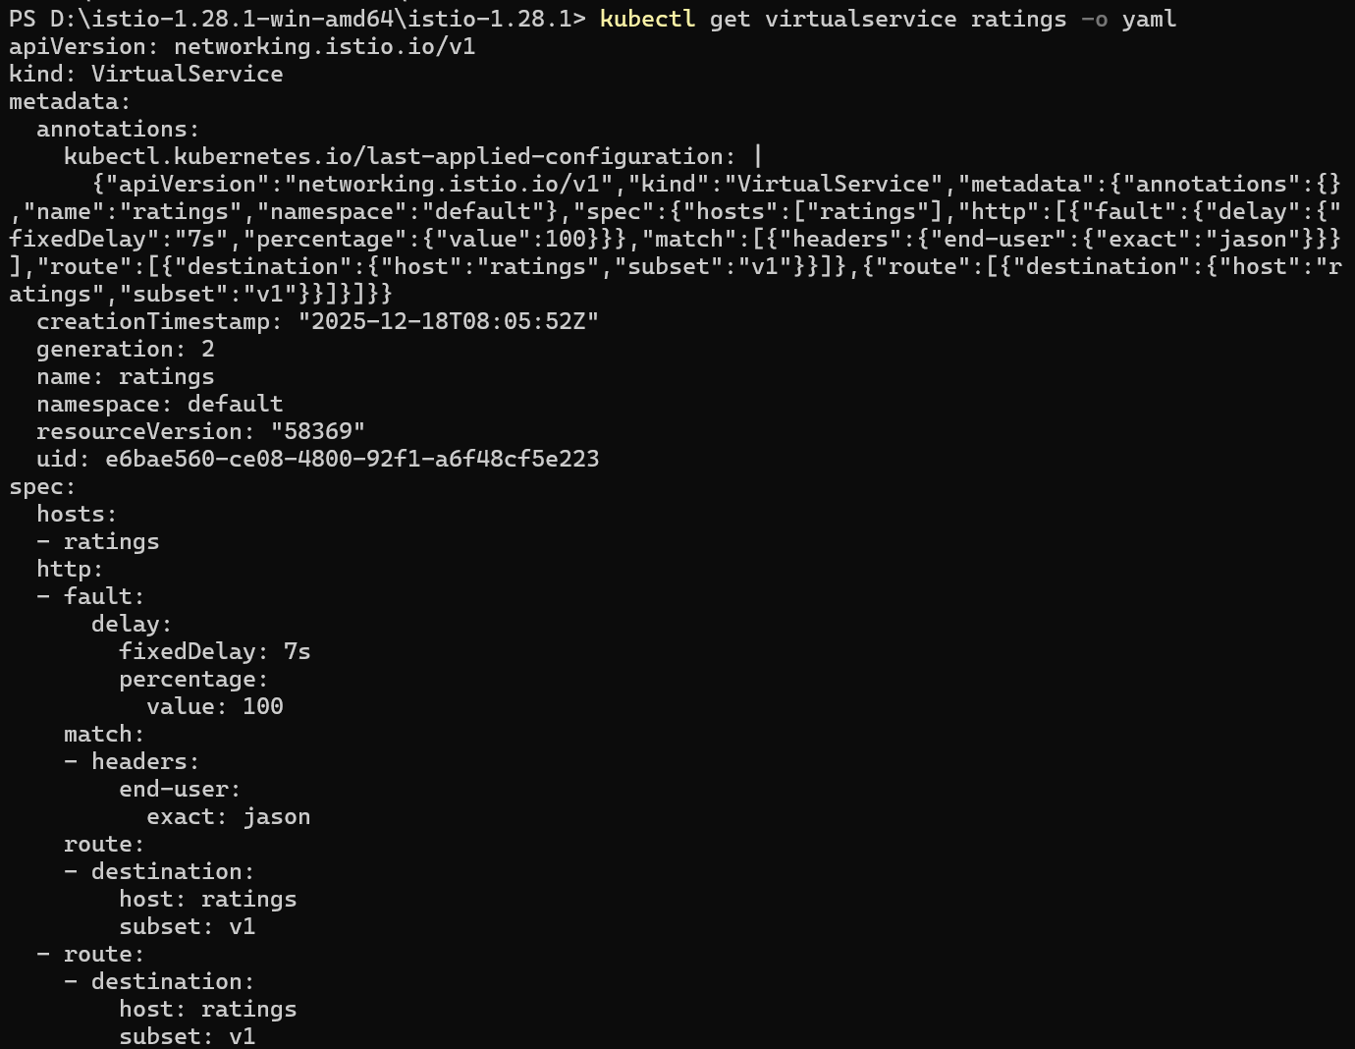

3.2 Testing the delay configuration
Open the Bookinfo web application in the browser.
On the /productpage web page, log in as user jason. We expect the Bookinfo home page to load without errors in approximately 7 seconds. However, there is a problem: the Reviews section displays an error message:

View the web page response times:
Open the Developer Tools menu in the web browser. Open the Network tab. Reload the /productpage web page. We see that the page actually loads in about 6 seconds.

We’ve found a bug. There are hard-coded timeouts in the microservices that have caused the reviews service to fail.

3.3 Injecting an HTTP abort fault
In this case, we expect the page to load immediately and display the Ratings service is currently unavailable message.
Create a fault injection rule to send an HTTP abort for user jason:
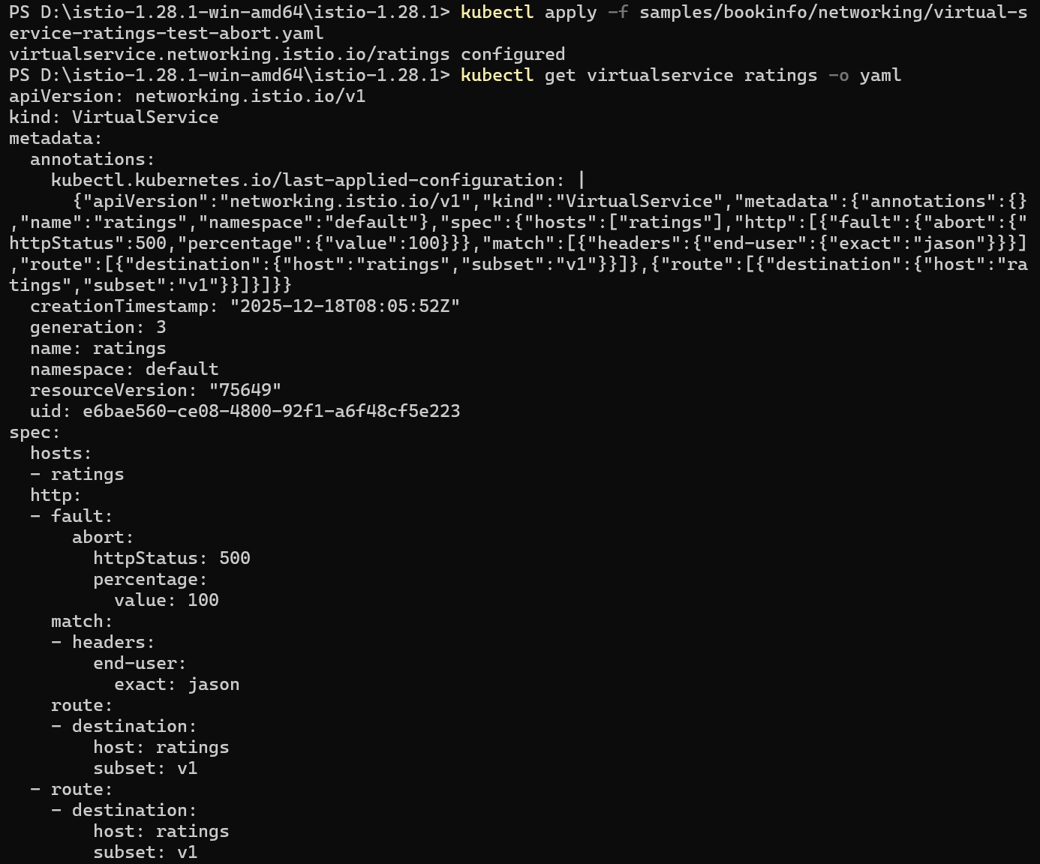
Open the Bookinfo web application in our browser. On the /productpage, log in as user jason. The page loads immediately and the Ratings service is currently unavailable message appears (Like the previous error picture).
If we log out from user jason or open the Bookinfo application in an anonymous window (or in another browser), we will see that /productpage still calls reviews:v1 (which does not call ratings at all) for everybody but jason.
Therefore, we will not see any error message.
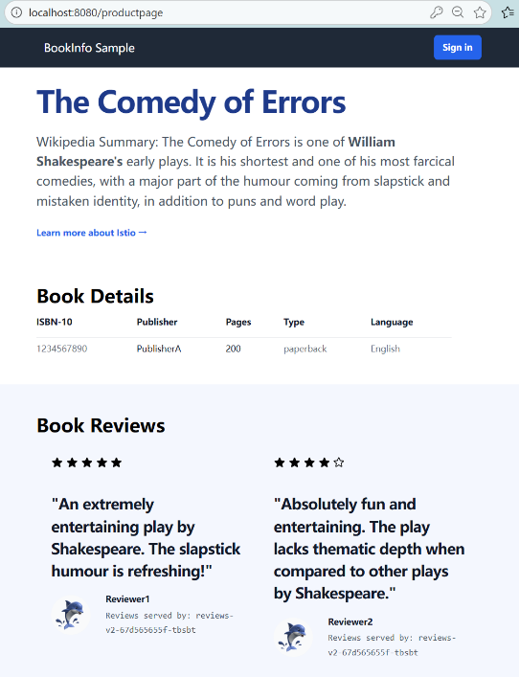

3.4 Cleanup
Remove the application routing rules:
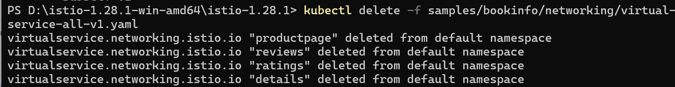

4. Circuit Breaking

4.1 Configuring the circuit breaker
Create a destination rule to apply circuit breaking settings when calling the httpbin service:
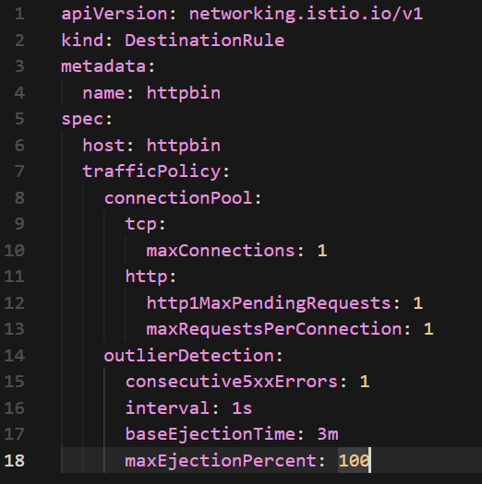
Verify the destination rule was created correctly:
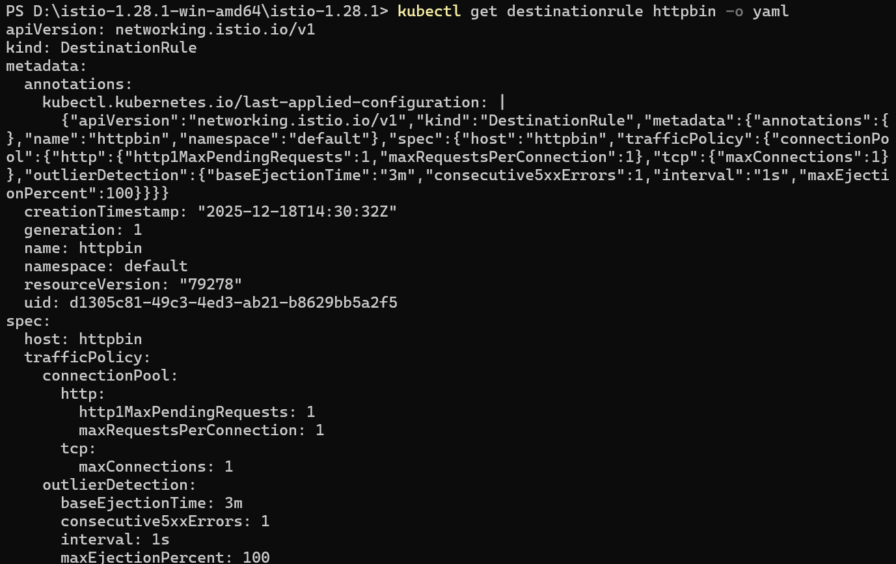

4.2 Adding a client
Inject the client with the Istio sidecar proxy so network interactions are governed by Istio.
If we have enabled automatic sidecar injection, deploy the fortio service:
Log in to the client pod and use the fortio tool to call httpbin.
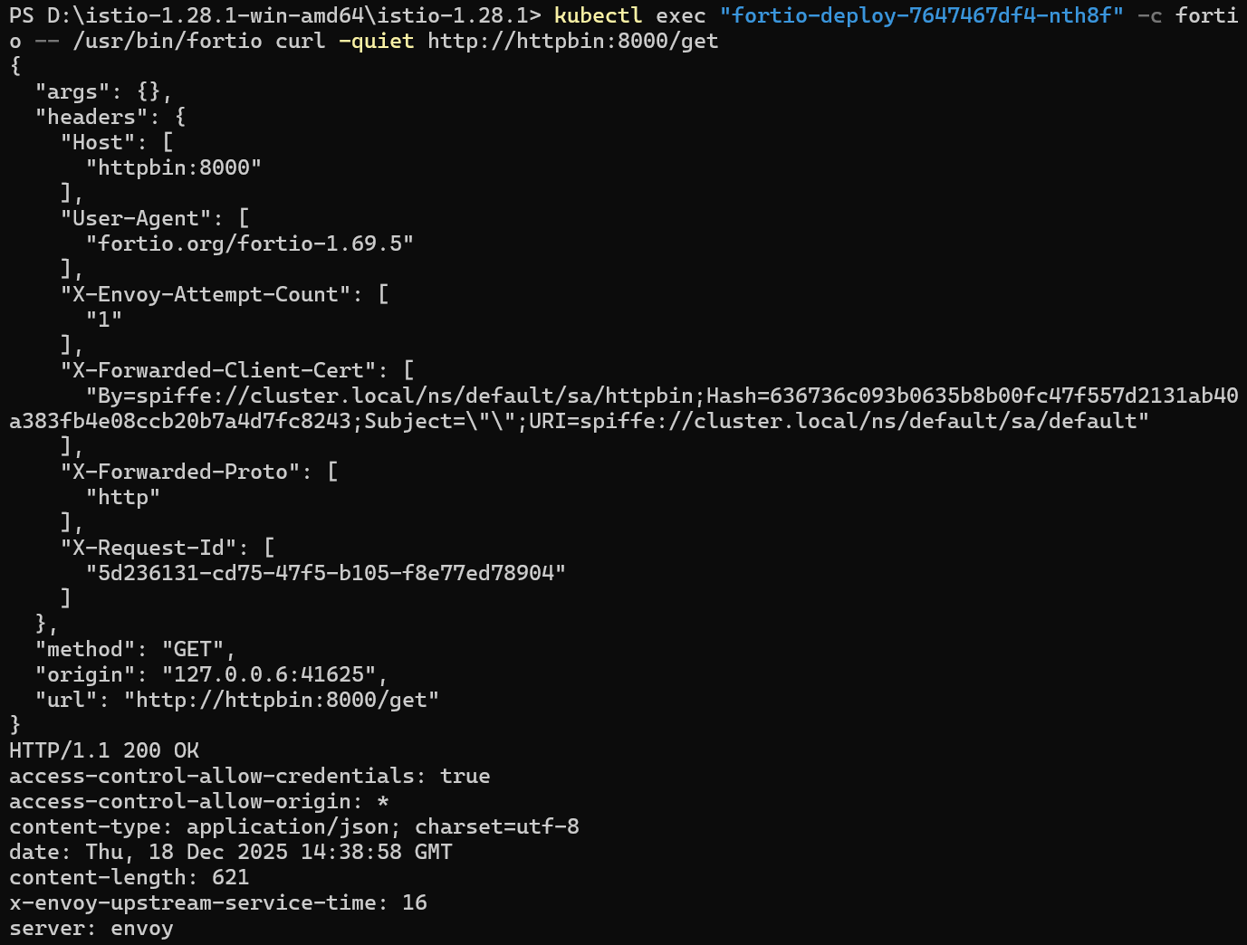
We can see the request succeeded!

4.3 Tripping the circuit breaker
In the DestinationRule settings, we specified maxConnections: 1 and http1MaxPendingRequests: 1. These rules indicate that if we exceed more than one connection and request concurrently, we should see some failures when the istio-proxy opens the circuit for further requests and connections.
Call the service with two concurrent connections (-c 2) and send 20 requests (-n 20):
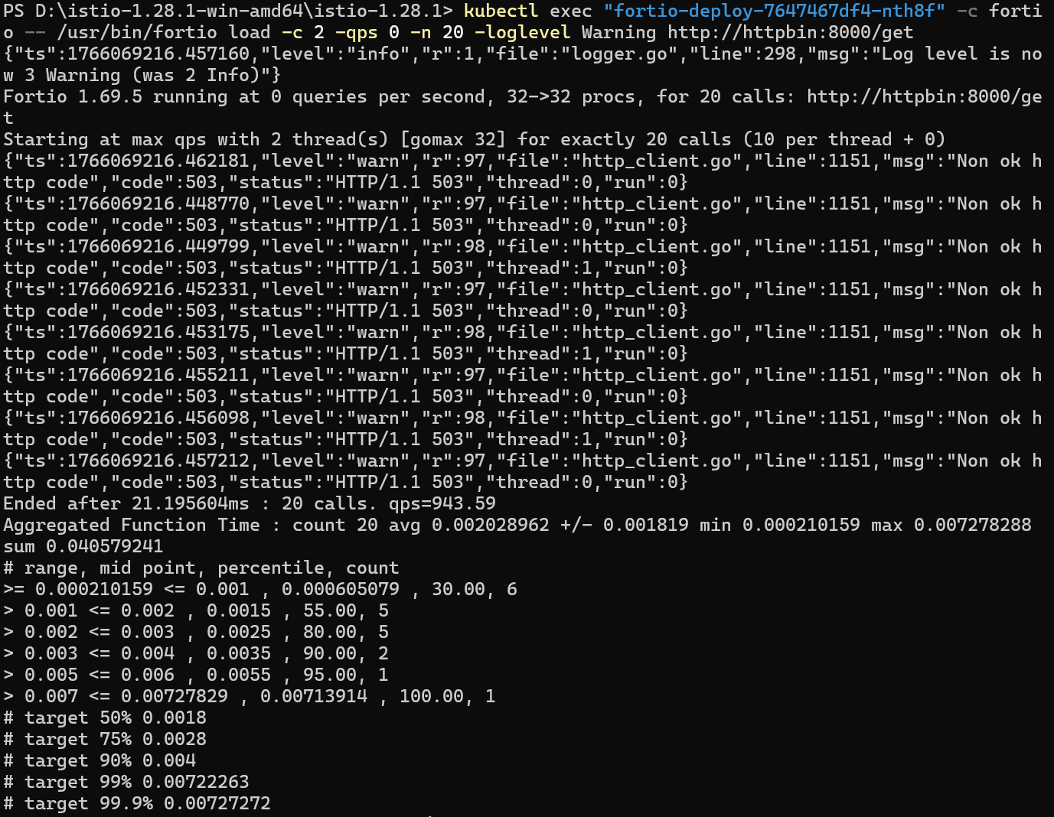
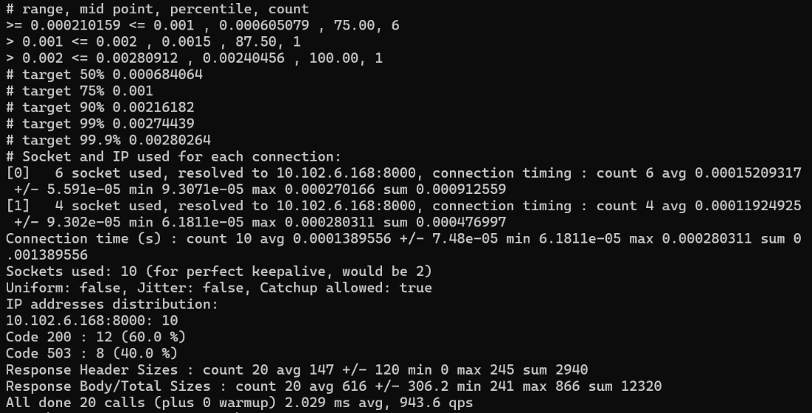
It’s interesting to see that almost all requests made it through. The istio-proxy does allow for some leeway.
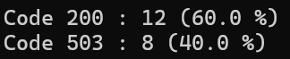
Bring the number of concurrent connections up to 3.
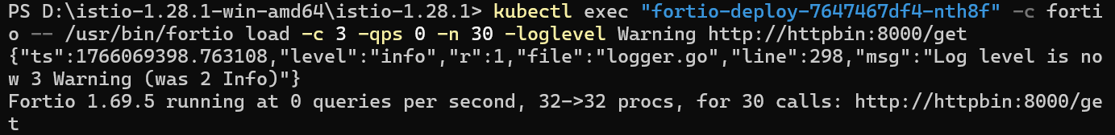
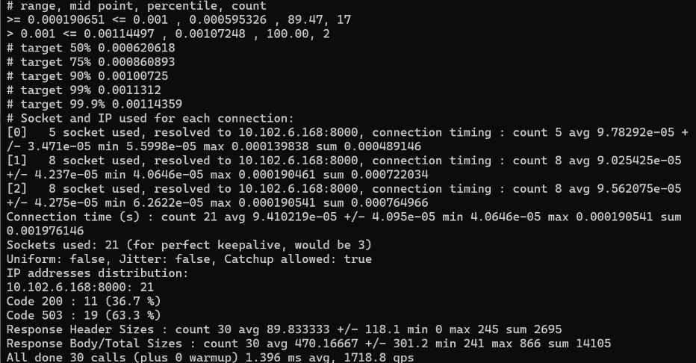
Now we start to see the expected circuit breaking behavior. Only 36.7% of the requests succeeded and the rest were trapped by circuit breaking:
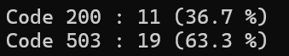
Query the istio-proxy stats to see more:
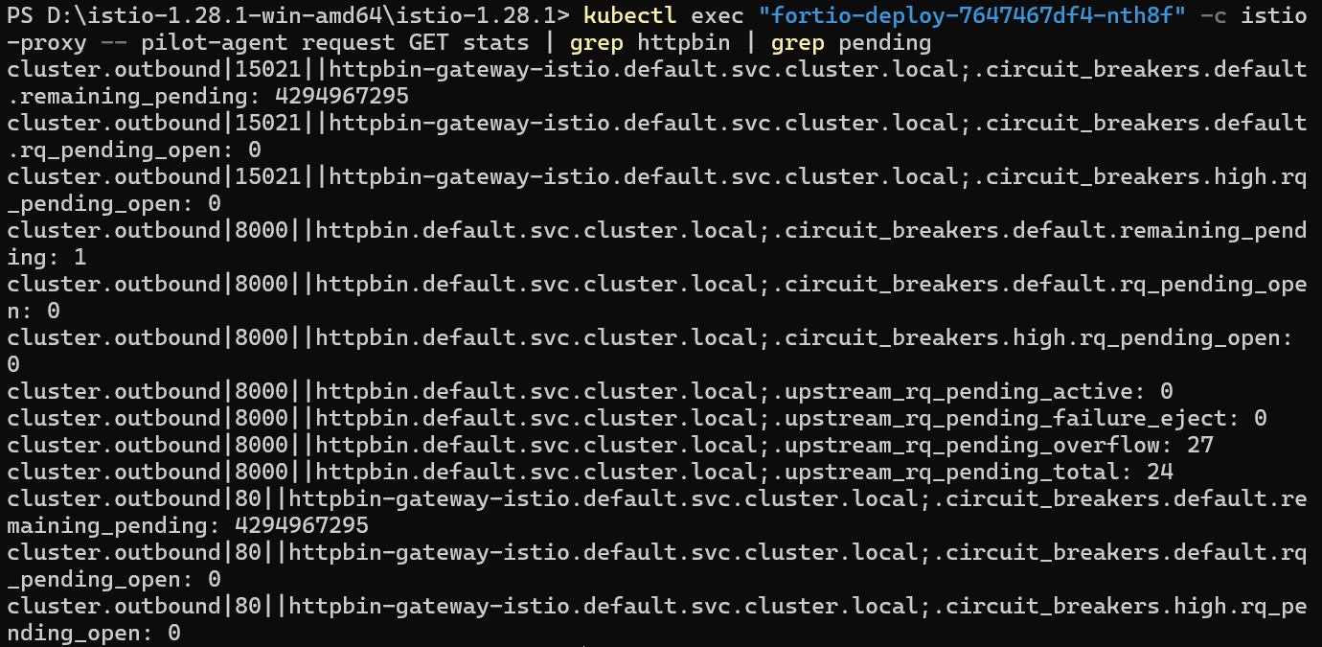
We can see 27 for the upstream_rq_pending_overflow value which means 27 calls so far have been flagged for circuit breaking.

4.4 Cleaning up
Remove the rules:
Shutdown the httpbin service and client:
